|  |
| --- |
| Experiment No.1 |
| Basic programming constructs like branching and looping |
| Name : Parth Sadanand Gawad |
| Roll no : 68 |
| Date of Performance: |
| Date of Submission: |

**Aim :-** To apply programming constructs of decision making and looping.

**Objective :-** To apply basic programming constructs like Branching and Looping for solving arithmetic problems like calculating factorial of a no entered by user at command prompt .

# Theory :-

Programming constructs are basic building blocks that can be used to control computer

programs. Most programs are built out of a fairly standard set of programming constructs. For example, to write a useful program, we need to be able to store values in variables, test these values against a condition, or loop through a set of instructions a certain number of times. Some of the basic program constructs include decision making and looping.

Decision Making in programming is similar to decision making in real life. In programming also, we face some situations where we want a certain block of code to be executed when some condition is fulfilled. A programming language uses control statements to control the flow of execution of a program based on certain conditions. These are used to cause the flow of execution to advance, and branch based on changes to the state of a program.

* if
* if-else
* nested-if
* if-else-if
* switch-case
* break, continue

These statements allow you to control the flow of your program’s execution based upon conditions known only during run time.

A loop is a programming structure that repeats a sequence of instructions until a specific condition is met. Programmers use loops to cycle through values, add sums of numbers, repeat functions, and many other things. Two of the most common types of loops are the while loop and the

for loop. The different ways of looping in programming languages are

* while
* do-while
* for loop
* Some languages have modified for loops for more convenience eg :- Modified for loop in java. For and while loop is entry-controlled loops. Do-while is an exit-controlled loop. **Code: -**

# NESTED IF-ELSE:

import java.io.*;

public class NestedIfElse{

public static void main(String args[]) { int age = 15;

boolean isStudent = true;

if (age >= 18) { if (isStudent) {

System.out.println("Adult Student");

} else {

System.out.println("Adult Non-Student");

}

} else {

if (isStudent) { System.out.println("Minor Student");

} else {

System.out.println("Minor Non-Student");

}

}

}

}

output

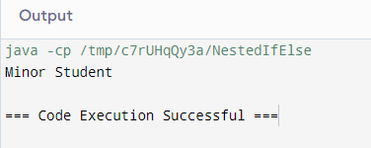

import java.util.Scanner;

public class Grade{

public static void main(String args[]) { Scanner sc = new Scanner(System.in);

System.out.print("Enter marks (0-100): "); int marks = sc.nextInt();

if (marks < 0 || marks > 100) {

System.out.println("Invalid marks. Please enter a value between 0 and 100."); } else {

int gradeCategory; if (marks >= 90) {

gradeCategory = 1;

} else if (marks >= 80) { gradeCategory = 2;

} else if (marks >= 70) { gradeCategory = 3;

} else if (marks >= 60) { gradeCategory = 4;

} else { gradeCategory = 5;

}

switch (gradeCategory) { case 1:

System.out.println("Grade: A");

break; case 2:

System.out.println("Grade: B"); break;

case 3:

System.out.println("Grade: C"); break;

case 4:

System.out.println("Grade: D"); break;

case 5:

System.out.println("Grade: F"); break;

default:

System.out.println("error"); break;

}

}

}

}

output

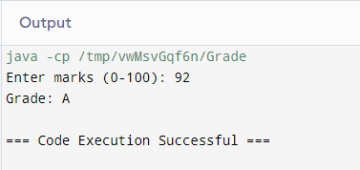

# FOR LOOP:

import java.io.*;

public class ForLoop {

public static void main(String args[]) { System.out.println("Numbers from 1 to 10:"); for (int i = 1; i <= 10; i++) {

System.out.println(i);

}

}

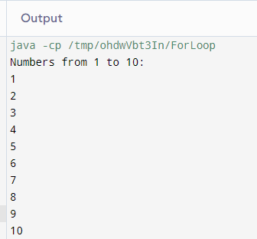

# DO WHILE LOOP:

import java.util.Scanner;

public class DoWhile {

public static void main(String[] args) { Scanner sc = new Scanner(System.in); int num;

do {

System.out.print("Enter a number (enter 0 to exit): "); num = sc.nextInt();

if (num != 0) {

System.out.println("You entered: " + num);

}

} while (num != 0);

System.out.println("Program has ended."); sc.close();

}

}

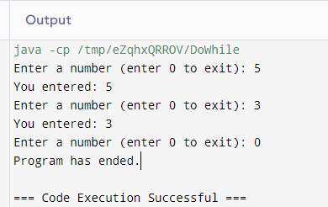

# Conclusion:

Branching (Decision-Making):

* **Purpose**: Branching allows us to make decisions based on conditions. It’s like choosing different paths in a maze.

Looping (Repetition):

* + **Purpose**: Loops allow us to repeat actions without writing the same code over and over.